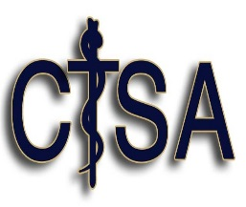

Notice to patients – Pain Medication Refill Policy

Due to a change in the Controlled Substance Act (a Federal regulation) combination hydrocodone products (which are commonly given following surgical procedures) will now require a special controlled substance prescription and no refills on that prescription are allowed.
The policy of Central Texas Surgical Associates is:
No controlled prescription will be refilled after hours Monday through Friday or on week-ends.

I am aware of this policy and should I require a refill of my pain medication, I will contact my physician’s office to make arrangements to pick up a controlled substance Rx during regular business hours.

__________________________________________________ ____________________________
Patient Date

Notice to patients – Electronic Recording Devices

To ensure confidentiality and privacy, any type of electronic recording device is strictly prohibited at any location within these offices.

Patient Acknowledgement

________________________________________________ _ ____________________________
Patient Date

