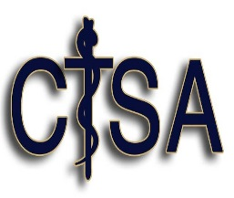

ACKNOWLEDGEMENT OF REVIEW
NOTICE OF PRIVACY PRACTICES

I have reviewed the Notice of Privacy Practices for Central Texas Surgical Associates, which explains how my medical information will be used and disclosed. I understand that I am entitled to receive a copy of this document.

________________________________________
Signature of Patient or Personal Representative

________________________________________
Date Signed

________________________________________
Name of Patient or Personal Representative

________________________________________
Description of Personal Representative’s Authority

